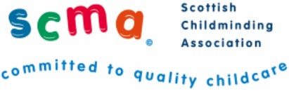
COVID-19 Childminding Fees

__________________________________________ (Insert name of childminding setting)
__________________________________________ (Insert address)
__________________________________________ (Insert email address)

This is to certify that my childminding setting is open/closed (delete as appropriate) due to guidance from Scottish Government in response to COVID-19.
With regard to the guidance from the Scottish Funding Council which states that:
- Where childcare providers are still open and the student’s child/ren are continuing to attend (they may meet the Government’s criteria for being able to continue to do so), then, yes, colleges should continue to pay these childcare costs.
- Where childcare providers are closed, or not available to the student’s child/ren any more (if they do not meet the Government’s criteria for being able to continue to do so), but the student has provided evidence to the college that the providers are requesting that all or some of the fees are still due as part of their COVID-19 policy then, yes, colleges should continue to pay these childcare costs.
I can confirm that it is the policy of my childminding setting to charge childcare fees during the current closure (either part/full/retainer). Therefore, fees are due and will continue to be charged as follows:

Child’s Name | Student’s Name | Part or Full or Retainer fees (please specify) | Fees due per week | Date due from

Childminder’s Name ………………………………………………………………
Date: ……………………………………………………………………………………..

*Please return this form to your local college who currently hold responsibility for paying student childcare fees.

